ASSIGNMENT COVER SHEET

Student’s name | Isaac | Patrickson
Module name | Software Engineering Fundamentals
Title of assignment | Software Engineering Fundamentals Final Assessment: Client Management System
Complete Word Count in my assignment

Date submitted

All work must be submitted by the due date. If an extension of time to submit work is required, a Mitigating Circumstances Extension Form must be submitted.

Has an extension been approved? Yes No If yes, please give the new submission date ….…/..…./…….

IMPORTANT: THIS STATEMENT MUST BE READ & SIGNED

Academic Integrity Statement

Academic integrity and honesty are fundamental to the academic work you produce at the University of Roehampton. You are expected to complete coursework that is your own and which is referenced appropriately. The university has in place measures to detect academic dishonesty in all its forms. If you are found to be cheating or attempting to gain an unfair advantage over other students in any way, this is considered academic misconduct and you will be penalised accordingly.
​
I declare that the work I am submitting is my work, is properly referenced and has not been submitted elsewhere.

Student Signature (Full Name): Isaac Patrickson

Date:

Table of Contents
Task 1: Design Document 4
Introduction 4
Project Purpose Definition 4
Application Overview 4
Instructions 5
Use Case UML Diagram 6
Program Activity UML Diagram 7
Abort Activity UML Diagram 8
Basic Class UML Diagram 9
Data Types and Validation Rules Specification (Make this an image at the end) 10
Program Structure 11
11

Task 1: Design Document

Introduction

Project Purpose Definition
Mediaworks Ltd, is a digital marketing company that requires a readily available, editable record of all clients, both active and inactive that can demonstrate to new employees the journey Mediaworks has taken to achieve its current position. They believe sharing successful partnership stories with well-known brands can increase employee satisfaction by making Mediaworks a company they are proud to work for.

Application Overview
The application I will develop will use SQLite library to create an embedded database that will store the data of Mediaworks clients in table records. Each record will have nine attributes: client ID, client name, contract status, contract start date, contract end date, whether project-based work is included in the contract, the longitude of the clients’ HQ, the latitude of the clients’ HQ, and the estimated total revenue generated. The client ID will be the primary key in the SQLite table and all requests to the table will be executed through a Python file.

I have chosen to use SQLite as it is simple, self-contained and serverless. It will be easier to set up and manage when compared to MySQL which requires a server. SQLite is lightweight and has a small footprint in terms of storage space and memory usage. This is important as employee devices may not be high end machines. Zero configuration is needed therefore employees do not require configuration files or user authentication, simplifying deployment and management. For small to medium-sized databases, SQLite can be faster than MySQL due to its in-process architecture, reducing the overhead of client-server communication. SQLite is also a public domain software, which can simplify licensing concerns that Mediaworks may have.

The program removes the need for curious employees to request internal reports which saves time within the business. This could also be used as a tool in the onboarding process to showcase the brilliance of Mediaworks to new employees.

Instructions
On startup the user will be prompted to login with a username. Upon a successful login, they will be shown the entire contents of the table, and then will be presented with an action menu. Depending on employee permissions, they will be given the option to amend, add, delete or display records. The user interface and the results of each request will be displayed to the user through the console. All inputs will be validated and all outputs will provide a clear description, to help create a user-friendly experience.

Upon selecting amend on the action menu, the user will be prompted to input a client ID linking to a record. The user will then need to select an attribute they would like to edit. Once an attribute is selected, they will need to input data to replace the existing data. The data is inserted into the selected place in the table, the table is displayed and the user is returned to the action menu.

When adding a record, the user will be prompted to input data corresponding to each attribute in the table. Each input will be validated and stored to an array. Once the user has completed the data input process, a record will be created with the attributes the user has entered (client ID automatically assigned). The table will then be displayed, showing the new record, and the user will be returned to the action menu.

When deleting a record, the user will be prompted to enter a client ID. Since all client ID values are unique, this will help avoid accidental deletions. The user will be asked to confirm whether they are sure if they want to delete the record with the selected ID. If the user’s answer is yes, the record will be deleted. The table will be displayed and the user will be returned to the action menu. Answering no will abort the process.

When displaying records, the user will be prompted to enter an attribute they would like to search by. The user is required to input their search data. Multiple records can be selected if the user decides to request based on a non-unique field (a user requesting for all active clients).

Use Case UML Diagram

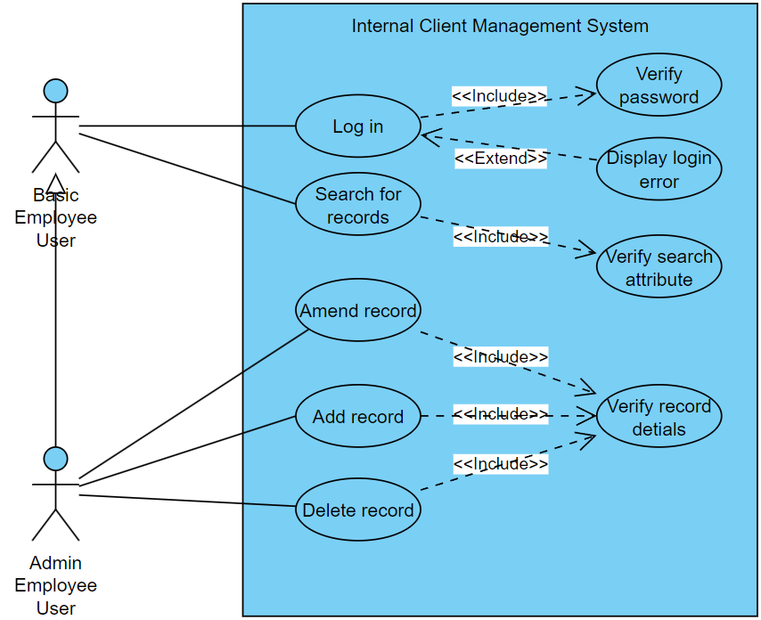

Program Activity UML Diagram
This Activity UML Diagram outlines the entire program (this activity diagram does not include the abort option for each user interaction stage)
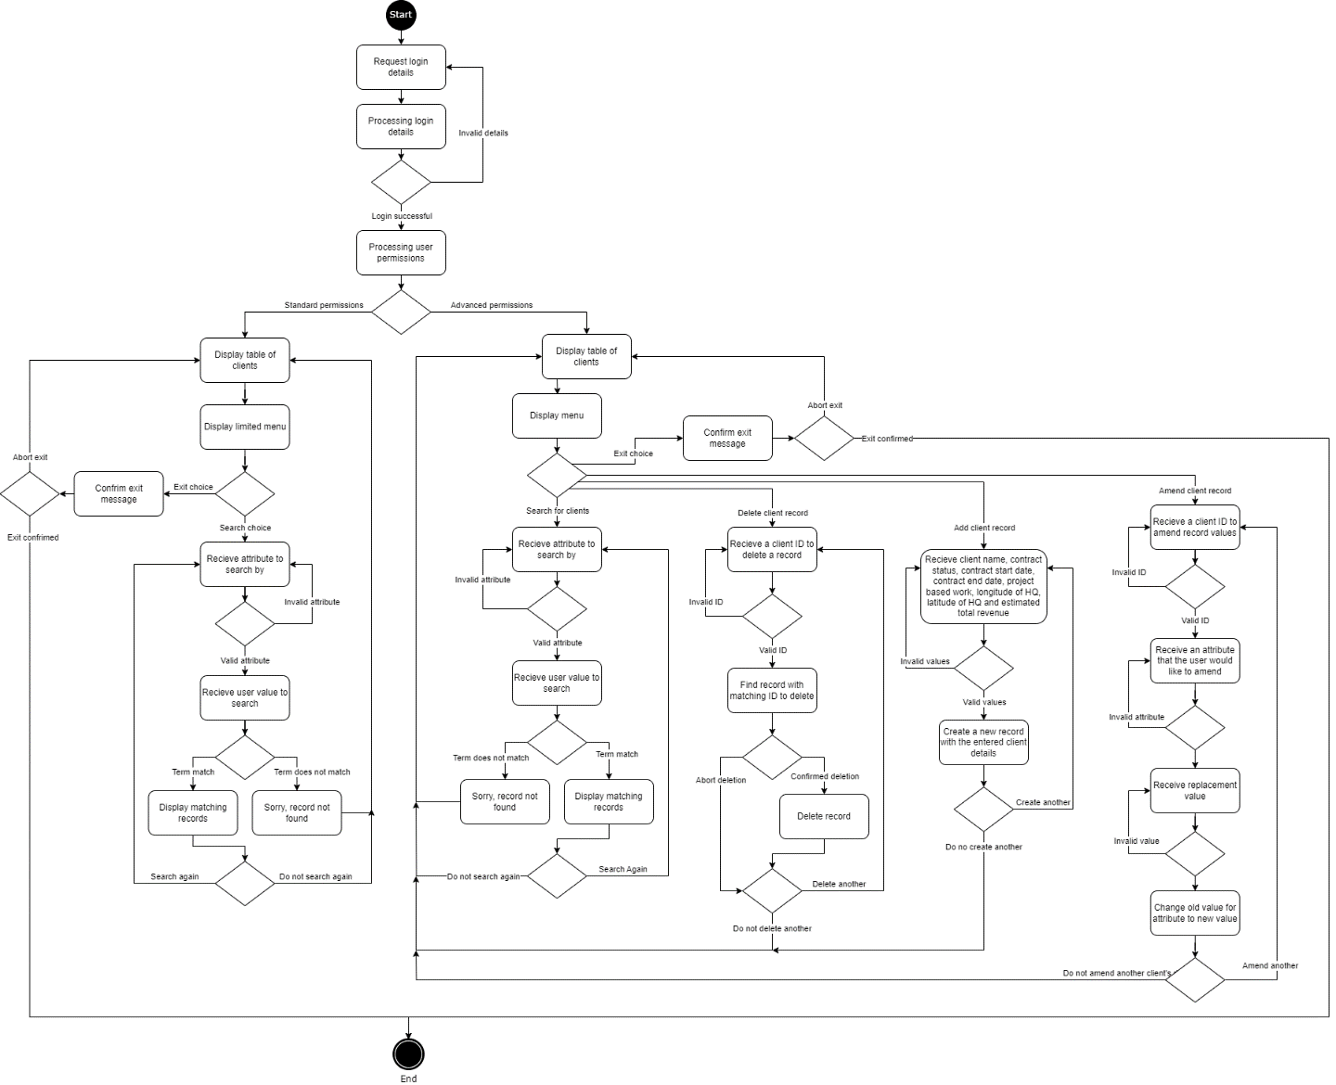

Abort Activity UML Diagram
This Activity UML Diagram outlines the user’s choice to abort at every input stage (the arrows highlighted in green represent the abort process and are not included in figure two)

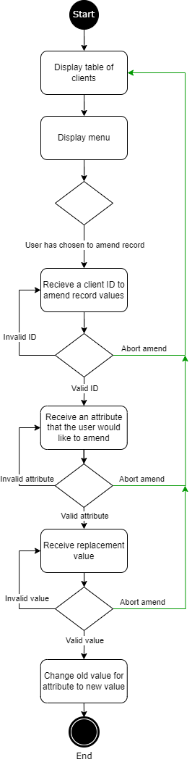

Basic Class UML Diagram
This Class UML Diagram highlights the attributes and methods in the classes I will use, as well as the relationships between each class.

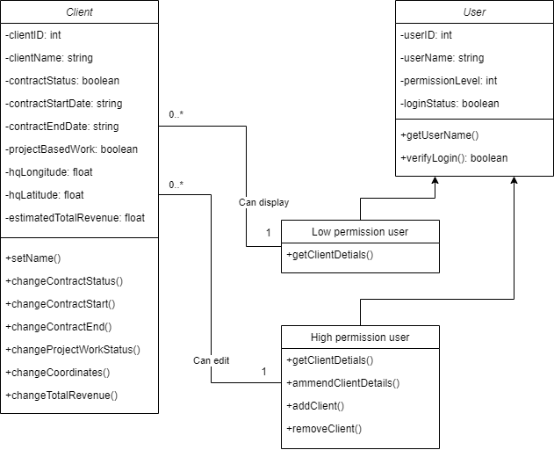
KEY
 | Is a child of…
 | 0 or many to one
- | Private
+ | Public

Data Types and Validation Rules Specification (Make this an image at the end)
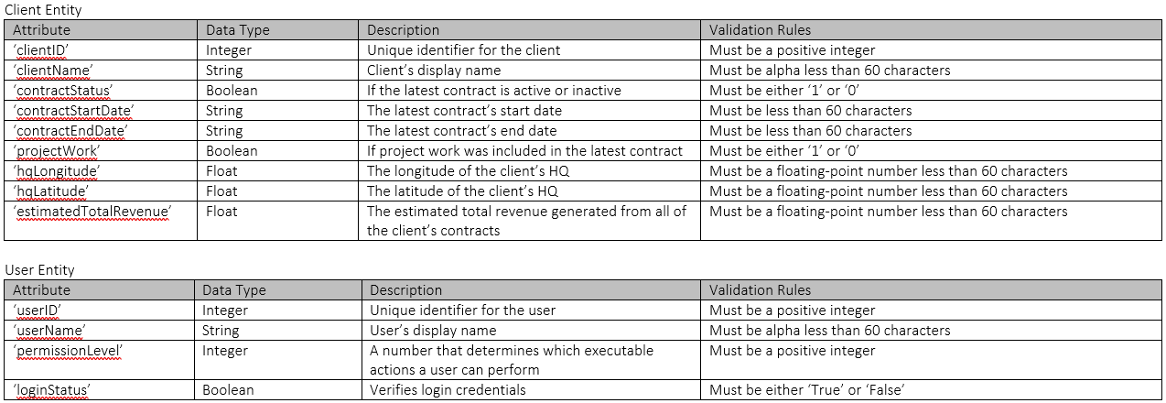

Program Structure

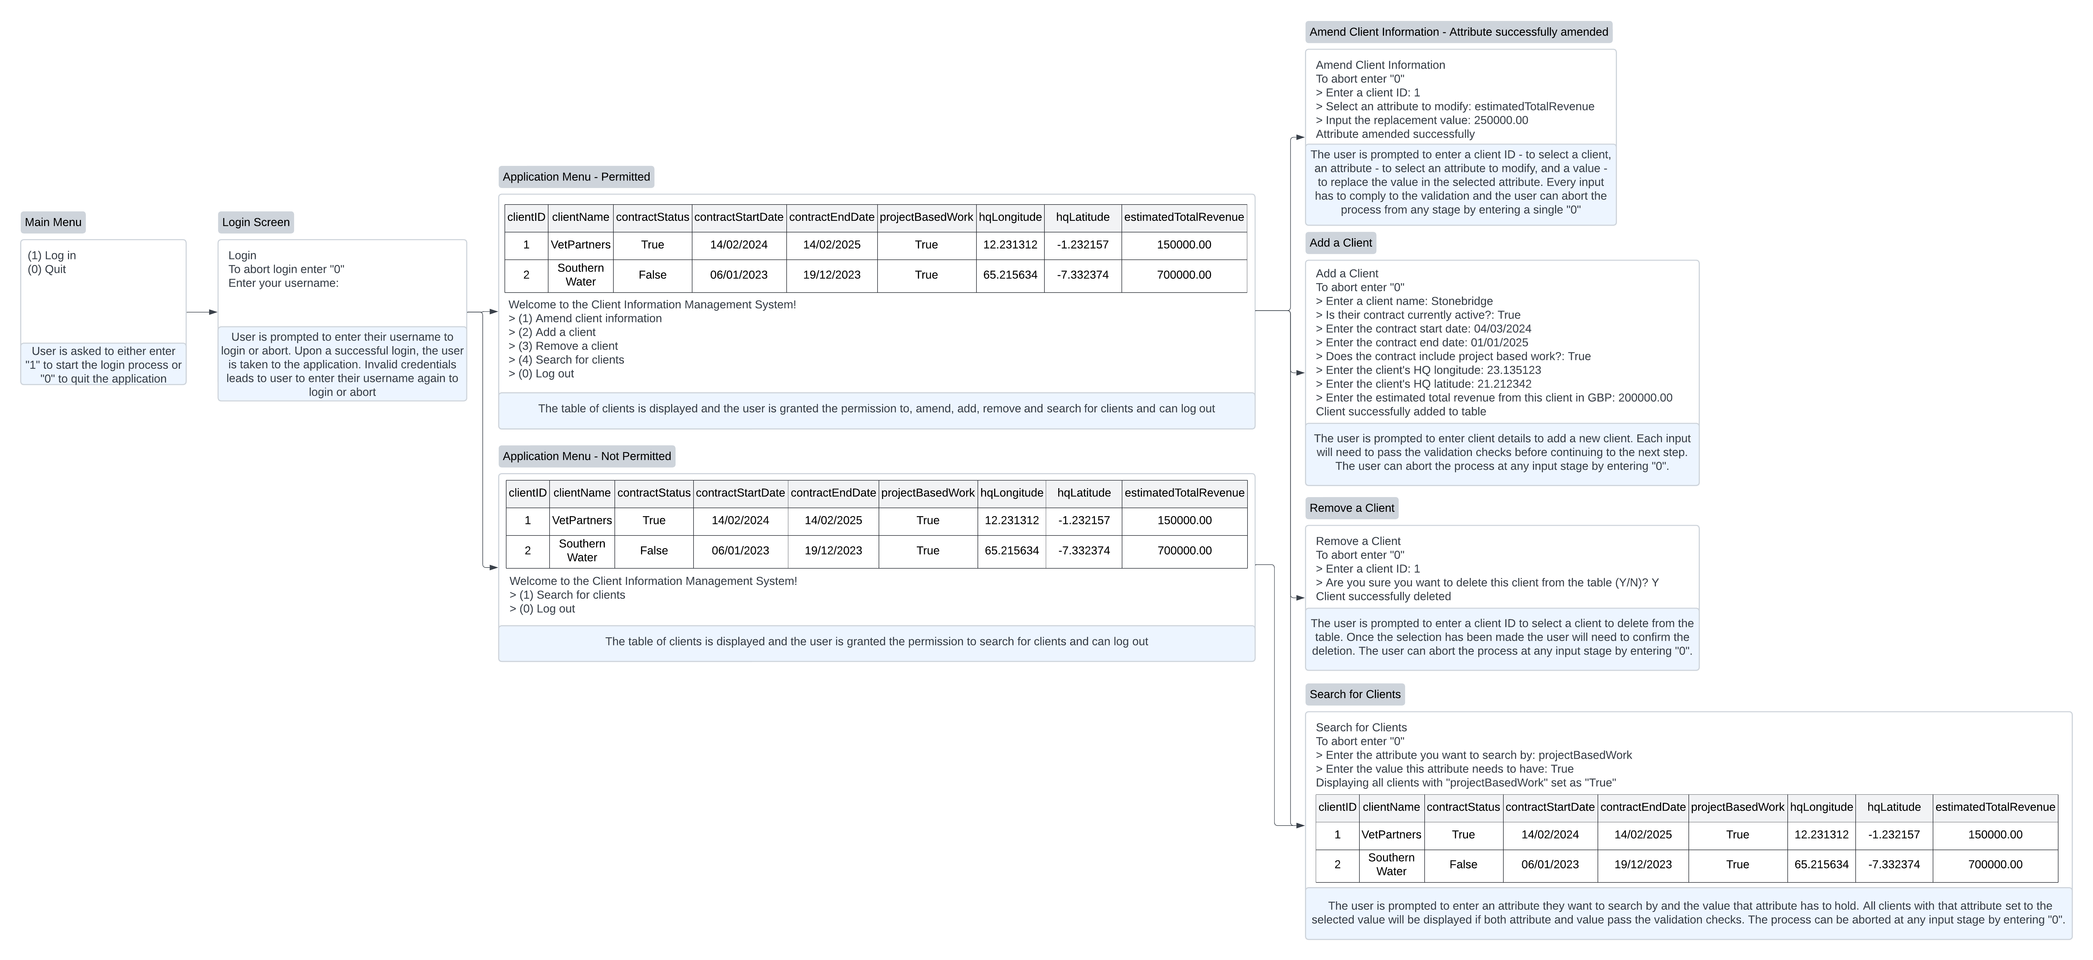
Task 3: Testing and the Manual Test Plan
I have chosen pytest when developing unit tests for my program. Tracebacks are provided making differentiating between passing, failing and skipped tests easy. I chose unit tests because it is a consistent and repeatable method of testing my code. Unit tests with pytest are less time-consuming and less error prone when compared to manual testing. ‘Unittest’ is a part of the python standard library, however it can be more verbose and less flexible than pytest. While methods such as integration testing are important, they are typically slower and more complex to set up. Unit tests focus on individual components which makes writing tests faster and easier and suits the criteria for this project.

Test data | Actions | Expected results | Test evidence

